Data Structure and Algorithm
Laboratory Activity No. 13

Tree Algorithm

Submitted by: | Instructor:
Caasi, Karl Benedict D. | Engr. Maria Rizette H. Sayo

November, 08, 2025

Objectives
Introduction
An abstract non-linear data type with a hierarchy-based structure is a tree. It is made up of links connecting nodes (where the data is kept). The root node of a tree data structure is where all other nodes and subtrees are connected to the root.

This laboratory activity aims to implement the principles and techniques in:
- To introduce Tree as Non-linear data structure
- To implement pre-order, in-order, and post-order of a binary tree
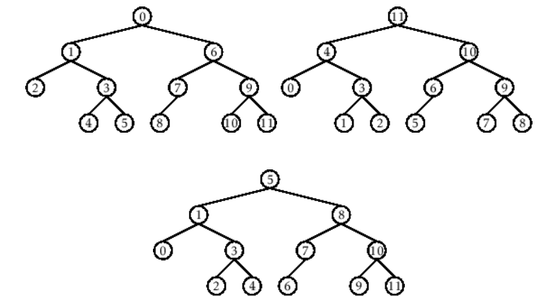

- Figure 1. Pre-order, In-order, and Post-order numberings of a binary tree

Methods
  - Copy and run the Python source codes.
  - If there is an algorithm error/s, debug the source codes.
  - Save these source codes to your GitHub.
  - Show the output

    - Tree Implementation

class TreeNode:
def __init__(self, value):
self.value = value
self.children = []

def add_child(self, child_node):
self.children.append(child_node)

def remove_child(self, child_node):
self.children = [child for child in self.children if child != child_node]

def traverse(self):
nodes = [self]
while nodes:
current_node = nodes.pop()
print(current_node.value)
nodes.extend(current_node.children)

def __str__(self, level=0):
ret = " " * level + str(self.value) + "\n"
for child in self.children:
ret += child.__str__(level + 1)
return ret

# Create a tree
root = TreeNode("Root")
child1 = TreeNode("Child 1")
child2 = TreeNode("Child 2")
grandchild1 = TreeNode("Grandchild 1")
grandchild2 = TreeNode("Grandchild 2")

root.add_child(child1)
root.add_child(child2)
child1.add_child(grandchild1)
child2.add_child(grandchild2)

print("Tree structure:")
print(root)

print("\nTraversal:")
root.traverse()

Questions:
- When would you prefer DFS over BFS and vice versa?
- What is the space complexity difference between DFS and BFS?
- How does the traversal order differ between DFS and BFS?
- When does DFS recursive fail compared to DFS iterative?

Results
Present the visualized procedures done. Also present the results with corresponding data visualizations such as graphs, charts, tables, or image . Please provide insights, commentaries, or explanations regarding the data. If an explanation requires the support of literature such as academic journals, books, magazines, reports, or web articles please cite and reference them using the IEEE format.
Please take note of the styles on the style ribbon as these would serve as the style format of this laboratory report. The body style is Times New Roman size 12, line spacing: 1.5. Body text should be in Justified alignment, while captions should be center-aligned. Images should be readable and include captions. Please refer to the sample below:

1.When would you prefer DFS over BFS and vice versa?
DFS is favored when:
• Before going back, you should thoroughly investigate a way.
• There is a memory restriction.
• The answer lies deep within the tree.
• For instance, figuring out puzzles or backtracking issues
BFS is recommended in:
The target must have the fewest edges or the shortest path.
The graph/tree is broad but shallow.
Finding the shortest paths or levels in a graph is an example.
.
2.What is the space complexity difference between DFS and BFS?
• DFS: $O(h)$— where h is the height (maximum depth) of the tree.
• BFS: $O(w)$— where w is the maximum width (maximum number of nodes at any level).

3. How does the traversal order differ between DFS and BFS?
DFS (Depth-First Search): Explores as deep as possible before backtracking.
- Example (Preorder): Root → Left → Right
- Order for tree: 1 → 2 → 4 → 5 → 3 → 6
BFS (Breadth-First Search): Explores level by level (top to bottom, left to right).
- Order for same tree: 1 → 2 → 3 → 4 → 5 → 6
4. When does DFS recursive fail compared to DFS iterative?
- DFS Recursive may fail if the tree or graph is very deep, causing a stack overflow (recursion depth exceeded).
- DFS Iterative avoids this problem because it uses an explicit stack data structure instead of the call stack.

CONCLUSION
Trees are an important part of computer science. A binary tree allows each node to have up to two children, while a general tree can have many. In a Binary Search Tree (BST), the smallest value is at the far left and the largest at the far right, making searches faster. A complete binary tree fills all levels from left to right, whereas a full binary tree makes sure every node has either zero or two children. To delete a tree safely, post-order traversal is best because it deletes all child nodes before the parent, avoiding leftover nodes.
REFERENCE
• Cormen, T. H., Leiserson, C. E., Rivest, R. L., & Stein, C. (2009). Introduction to Algorithms (3rd ed.). MIT Press.
• Weiss, M. A. (2013). Data Structures and Algorithm Analysis in C++ (4th ed.). Pearson.
• GeeksforGeeks. (n.d.). Tree Data Structure. Retrieved from https://www.geeksforgeeks.org/binary-tree-data-structure/
• Kleinberg, J., & Tardos, É. (2005). Algorithm Design. Pearson.

